**Chapter 12: TYPE QUALIFIERS & CASTING**

**Topic – 1: Type Qualifiers**

**Introduction**

* Keywords used to modify **property** of variables.
* There are 3 main type qualifiers – **const**, **volatile**, **restrict**.

**Constant**

* Used to define any kind of variable as **read-only** (**constant**).

***const int PI = 3.14;***

* Still, we can change value of a **constant variable** like **PI** here using a **pointer**.

***const int PI = 3.14;***

***int *ptr = (int *)&PI;***

***\*ptr = 8.51***

**Volatile**

* To understand how **volatile** keyword works, we need to know about how data are stored in **memory**.
* So, we use keyword **volatile** to tell compiler **not** to apply **optimization** to certain variables.

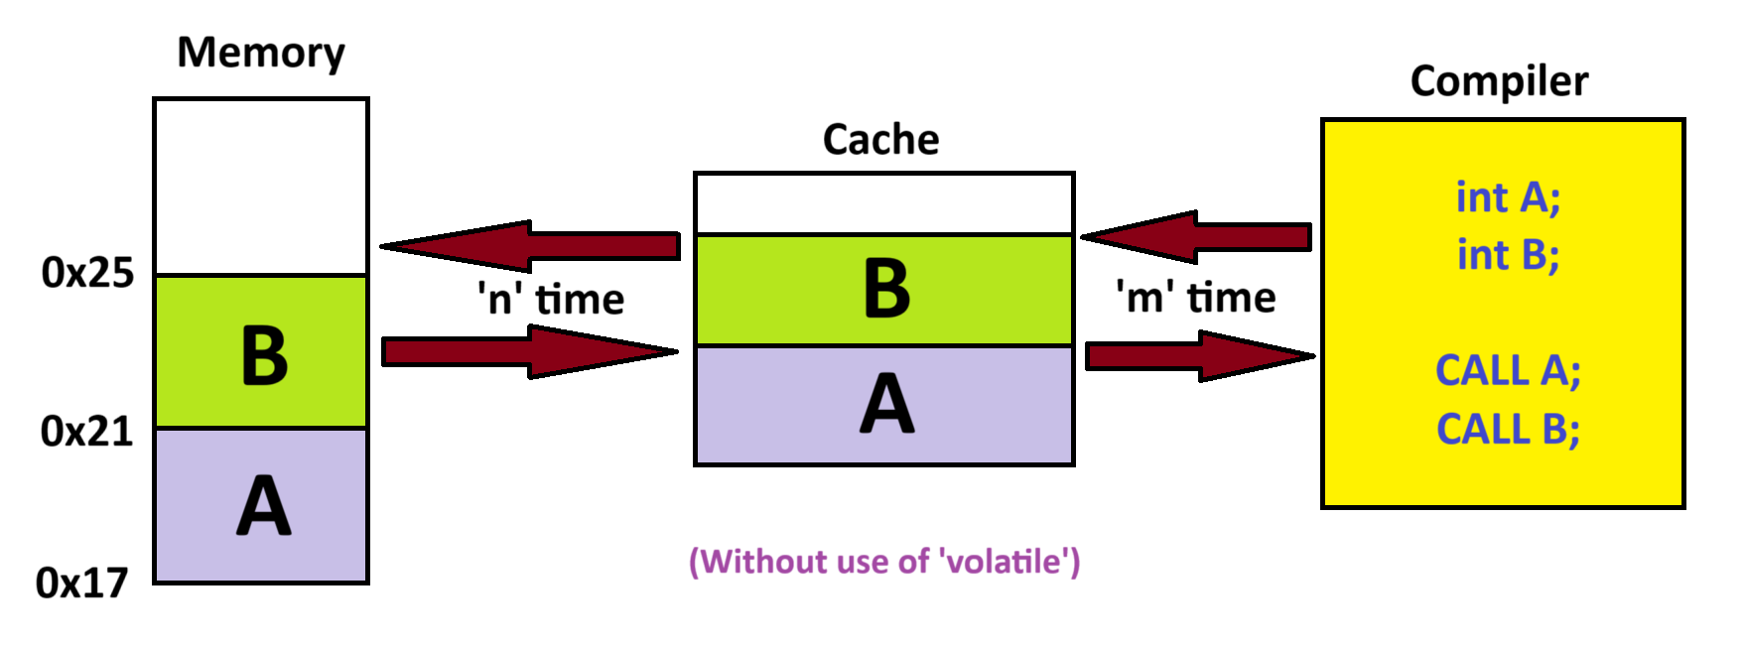

* Now suppose some change made at the **memory address** of **B** through **interrupt**.
* This change **won’t** be noticed by compiler as it refers to **cache** only for accessing variables.
* And it takes time **'m'** to be accessed.

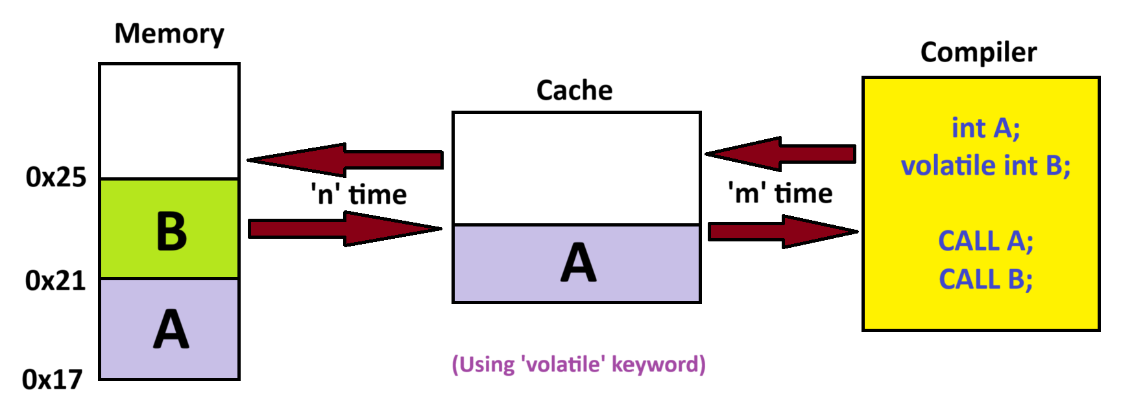

* As we have declared variable **B** as **volatile**, the compiler will access **B** through **memory address** & not **cache**.
* Also note that this takes **time** **(m + n)** to be **accessed** as **no** optimization is applied.
* Though, **A** will be accessed through cache being **non-volatile**.

***volatile int x = 5;***

***volatile int *ptr = (volatile int *) 0x4000; // or &x instead of 0x4000***

* Volatile are often used in places like **embedded systems** & **OS kernels** etc.
* When we want to tell the compiler that a variable can change under certain **external events** like **change at memory address**, **interrupt** or any **hardware changes**.
* This is necessary as compiler **doesn’t** always considers all hardware conditions.

**Restrict**

* Keyword **restrict** is again used for **optimization** purposes.
* It is however used along **pointer variables**.
* It makes sure that for all the mentioned **restrict** pointers, they **don’t** point to **overlapping memory**.

***void add(int *restrict a, int *restrict b)***

***{***

***/* Some codes */***

***}***

**Restrict Example**

* Say we pass two **pointers** **A** & **B** pointing to **variable** **P** to our function.

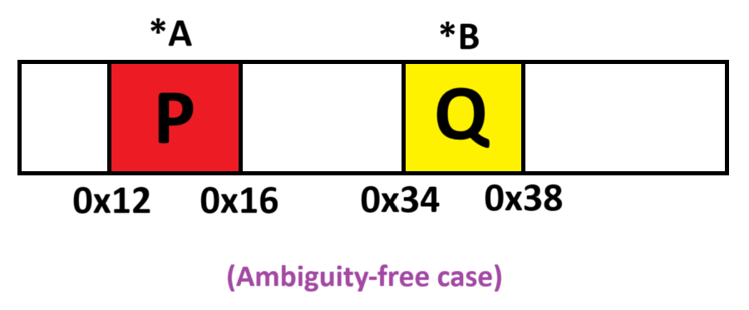

* Now let’s say instead both **A** & **B** point to **P**.

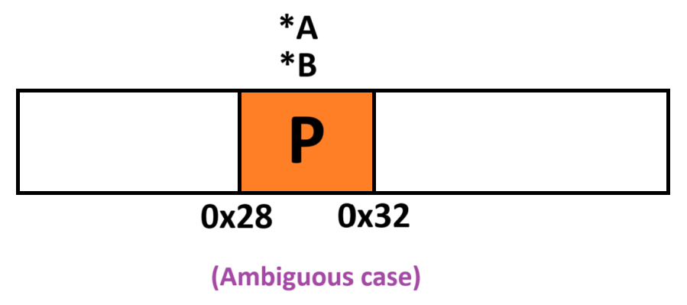

**Topic – 2: Casting**

**Implicit Type Casting**

* These are **automatically converted** by compiler when found.

***/* Integer to float */***

***int x = 5;***

***float y = x + 3.5; // y = 8.5***

***/* Character to integer */***

***char a = 'A';***

***int x = a; // x = 65 (ASCII value)***

***/* Boolean to integer (for C++) */***

***bool flag = true;***

***int res = flag + 10; // res = 1 + 10 = 11***

* Other examples include – **int** to **double**, **unsigned** to **signed** & **short** to **long** etc.

**Note!**

**🡪 Terms like short & long comes under category of precision keywords.**

**Explicit Casting**

* Now you know what it is.
* **Explicit casting** is **safer** as we inform compiler what we are doing.
* Examples will be same as all we did in **implicit type casting** but with **safety**.

**Tips!**

**🡪 It is advised to use explicit casting wherever possible, as there is no difference in overhead for both types of casting.**

***/* Float to integer */***

***float PI = 3.14;***

***int x = (int) PI; // x = 3***

***/* Integer to ASCII */***

***int ascii = 65;***

***char c = (char) ascii; // ASCII 65 = 'A'***

***/* Pointer cast conversion */***

***int x = 7;***

***void *ptr = &x; // We don’t do any explicit casting for (void *)***

***int *ptr2 = (int *) ptr; // Points to 'x' and is of type integer***

**Note!**

**🡪 We can do conversions between regular numeric data types & precision numeric data types too.**